1. CHILD’S NAME:

__________________, _________________, __________________
Last Name First Name Middle Name/s

Home (Mailing) Address:

______________________________________________________________________

_______________________________________ Postal Code:___________________

Birthdate: (YYYY/MM/DD) ______ /____/____ Age Sept 2020____ Age Sept 2021____
Age Sept 2022____ Age Sept 2023____

2. APPLYING FOR:

Parent and Child Program, 2020-2021 (ages 2 to 3, Fridays 10:30 to noon) ___yes ____no
And/Or
Playschool Program (ages 2 yrs, 10 months to 5 years, 10 months - your child cannot turn 6 within the school year)

Desired Date of Entrance to Playschool: _________/______ /______ YYYY / MM / DD

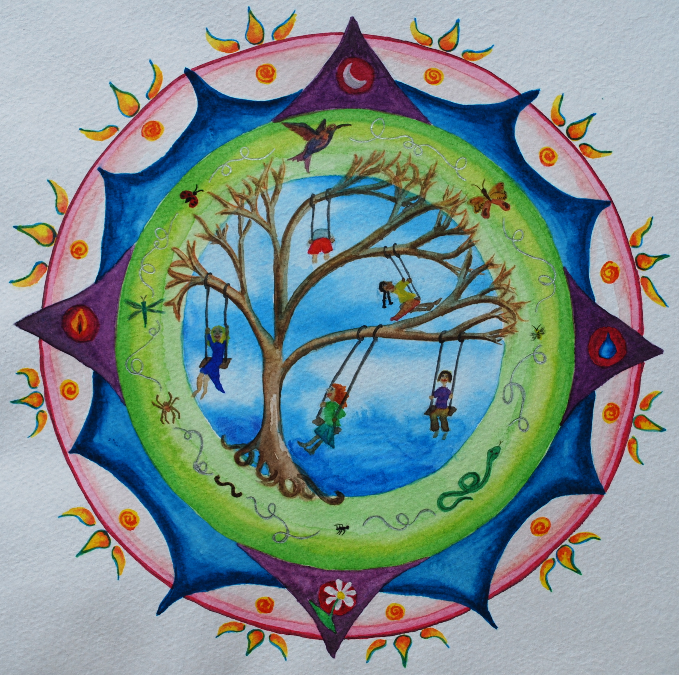
Hours of Care Requested: possible options are Mo.n to Fri. 9:00 to 3:00, 2 days a week 9:00 to 3:00 (Thurs. and Fri.), 3 days a week 9:00 to 3:00 (Mon., Tues. and Wed) or half days 9 to12:30 (Tue./Wed./Thurs.)

Indicate which days are preferred:

MON______ TUES______ WED______ THURS______ FRI______

Provide more details if necessary____________________________________________________

3. PARENT/GUARDIAN INFORMATION
Parent/Guardian #1

________________________, ________________________
Last Name First Name

Relationship to Child: __________________________________

Full Mailing Address (if different from the child’s full mailing address above):

________________________________________________________Postal Code:___________

Phone: ________________________ 2nd Phone:____________________________

Email Address for correspondence: _______________________________________
Parent/Guardian #2

________________________, ________________________
Last Name First Name

Relationship to Child: __________________________________

Full Mailing Address (if different from the child’s full mailing address above):

________________________________________________________Postal Code:___________

Phone: ________________________ 2nd Phone:____________________________

Email Address for correspondence: _______________________________________

Custody Arrangements (if applicable)
Are there custody arrangements pertaining to legal right of access to your child? ___YES ___ NO
If YES, please provide a copy of the appropriate legal documentation (e.g., court order).

Name(s) of custodial parent(s): _______________________________________

4. PARENT/GUARDIAN SIGNATURE:

Date of Application: (YYYY / MM / DD) ________/____/____

Printed Name of Parent/Guardian completing this form:

____________________________________________________________________

I have read Tree of Life Playschool’s Policies and Procedure: ___yes ____no

Signature of Parent/Guardian: _____________________________________________

5. RETURN THE COMPLETED FORM TO:
Kate Lawes, Director - Email: kate@mumbo.ca

SEND $50 non refundable Initial Intake Form Fee by e-transfer to kate@mumbo.ca
(Security Question: What city do we live in? Answer: Victoria)

Thank you for your interest in Tree of Life Playschool, I will be in touch with you soon about arranging a personal tour.

Kate Lawes, Director, Tree of Life Playschool

For Office Use Only:
Application Received Date: _____________________Waitlisted: ___________________________

Application Fee Paid: ___________________Directors Signature:___________________________

